Migration of email from Google to Microsoft 365
Prereq:
****The account on Google Workspace must be a Super Admin. If it is not there will be errors when setting up the API links
- Files needed: TPT - Google Workspace to O365 Email Planning Document
- Download Advanced GAM https://github.com/taers232c/GAMADV-XTD3
- Python 3
- Other userful GAM scripts: https://github.com/taers232c/GAM-Scripts3
- https://github.com/taers232c/GAM-Scripts3/blob/master/GetSharedFiles.py
- Download ShowDelegators.py

Get the Data

- We need to run an Advanced GAM project in order to export groups and users in bulk.
  - Download Advanced GAM https://github.com/taers232c/GAMADV-XTD3
  - Install GAM – (Install to C:\GAMADV-XTD3)
  - In an elevated command prompt change to C:\GAMADV-XTD3
  - Create a GAM project (run the command "gam create project")
  - Login to start the process
  - When the initial setup is complete login with the provide web site
  - Select Desktop App
  - In the Name field type Discovery
  - Copy the client ID to get pasted into GAM
  - Get all user information
    - Gam print users allfields > C:\ GAMADV-XTD3\allusers.csv
  - Get all group members
    - gam print group-members > c:\ GAMADV-XTD3\Group.members.csv
  - Get all resources
    - gam print resources > C:\gam\Resources.csv
- Place the results in the tabs for Groups and Resources in the workbook
- Download and install Python. This will allow the gathering of Delegates
  - gam redirect csv ./AllDelegates.csv all users print delegates shownames
  - python3 ShowDelegators.py ./AllDelegates.csv ./AllDelegators.csv

Implementation

- Use the file O365 Multiple User Import.csv or use the below to download a fresh copy.
  - Log into O365 at https://admin/microsoft.com
  - Under Active users click the menu Add Multiple Users
  - Click I’d like to upload a CSV with user information
  - Click Download a CSV file with the required headers
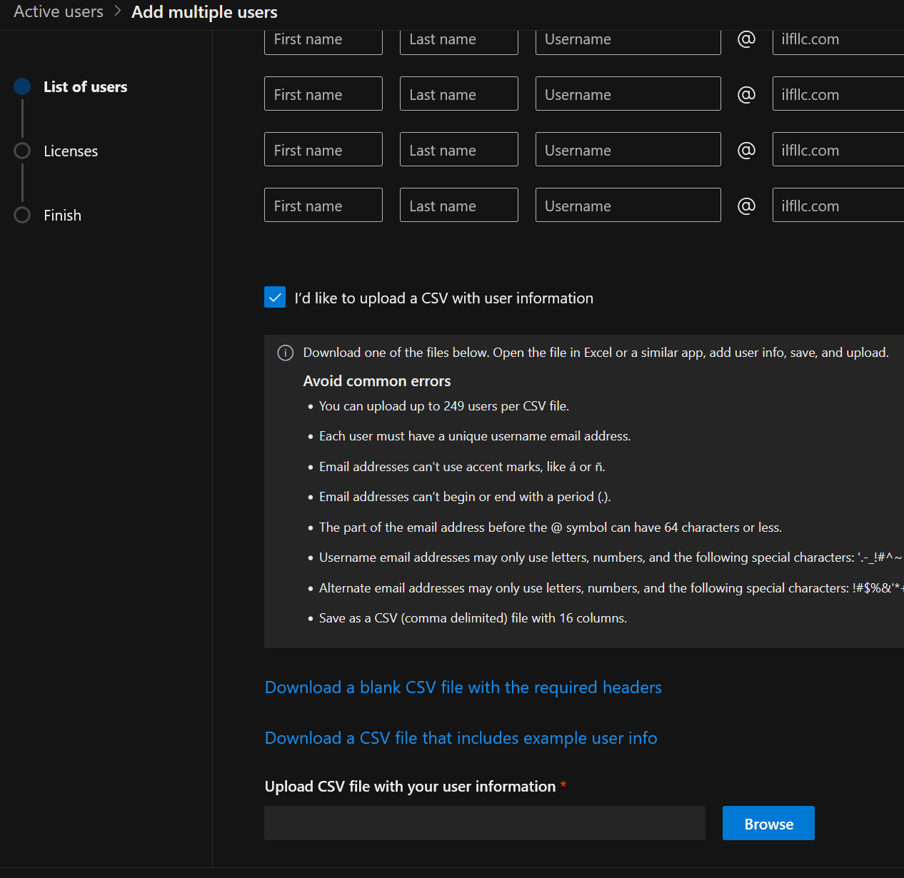
- Open the downloaded template or the file from step 1 in Excel
- The following columns need to be copied from the User list to the O365 template
  - Column AJ -> Column B
  - Column AH -> Column C
  - Column A -> Column A
  - Column AI -> Column D
  - Column AQ -> Column E
  - Column AN -> Column F
  - Column AS -> Column H
  - Column P -> Column I
  - Column C -> Column K
- Save the template file to csv with the name <Partner Name>_Import_Users_List.csv
- Navigate to Microsoft 365 Admin center -> Users -> Active Users -> -> click “Add multiple users”
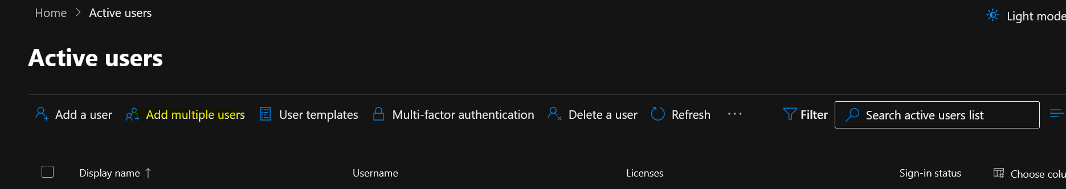
- Check the box “I’d like to upload a CSV with user information” and upload “<Partner Name>_Import_Users_List.csv”
Exchange
- You next need to create your CSV or multiple CSVs for the migration. The CSV will have two columns, EmailAddress and UserName. The email address will be the Microsoft 365 UPN and the UserName is the email address for Google Mail. At the time of this document, this is a manual process, as I have not yet created the macro to do this. The migration batches can be broken up into many batches if you like.
- Navigate to M365 Exchange Admin Center
- Click Migration
- Click on “Add migration batch”
- Give the migration batch a unique name and “Select the mailbox migration path” to “Migration to Exchange Online”.
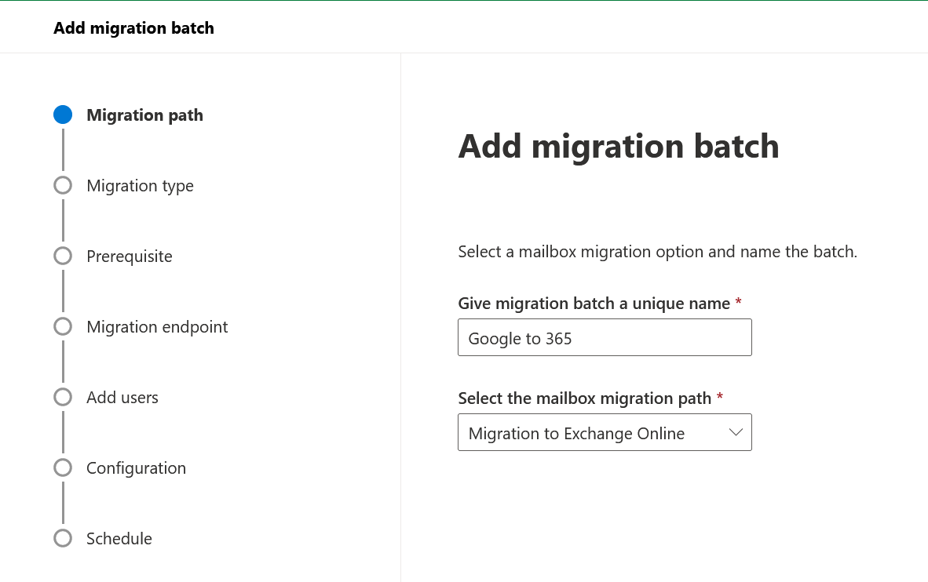
- Select the migration type to “Google Workspace (Gmail) migration”.
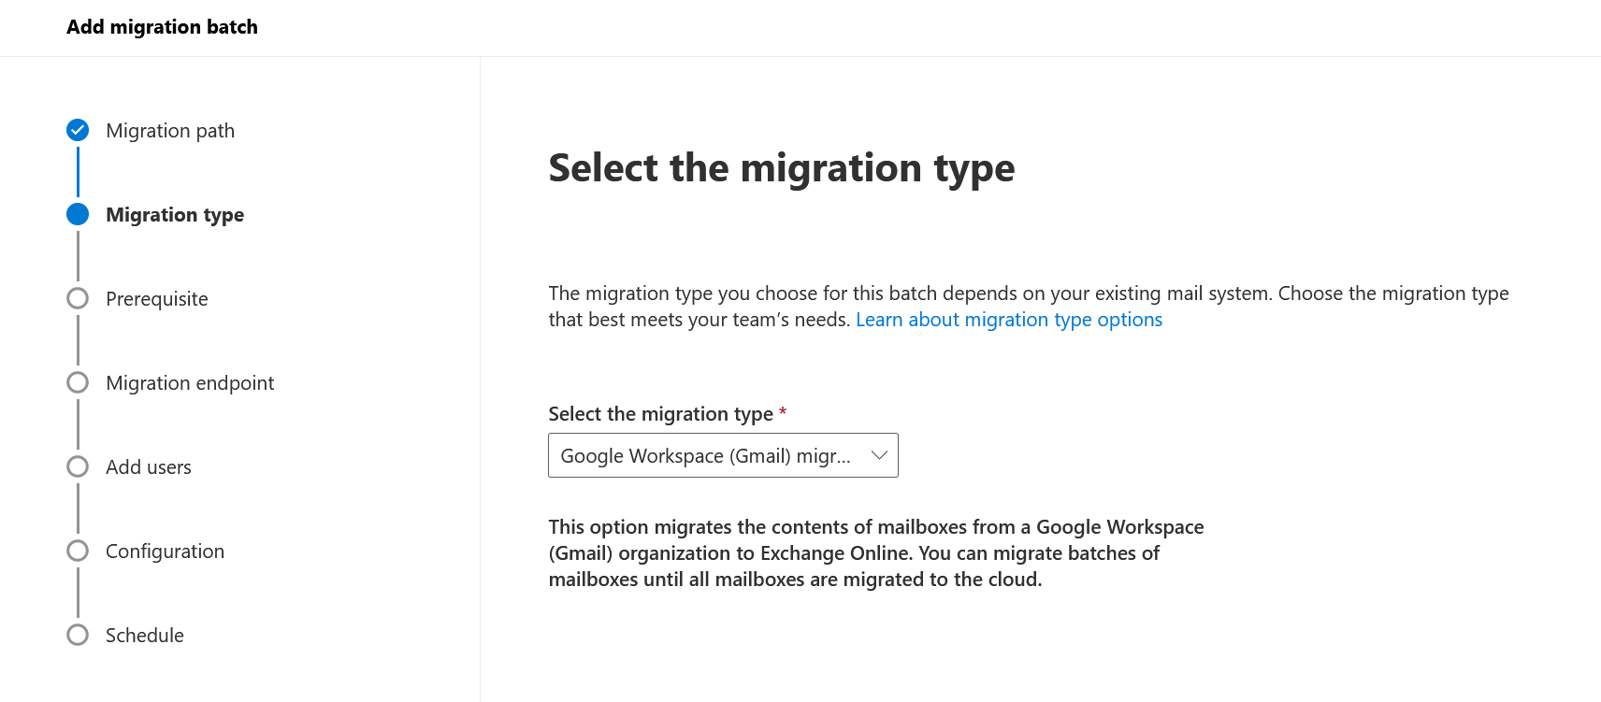
- Automate the configuration of your Google Workspace for migration. Click “Start”
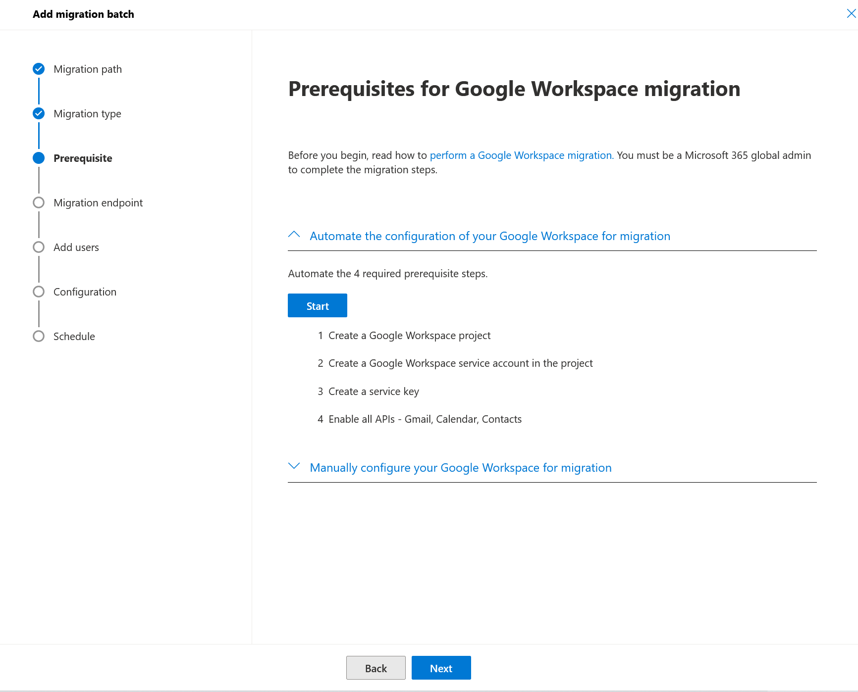

- Authenticate with your Google Admin account:
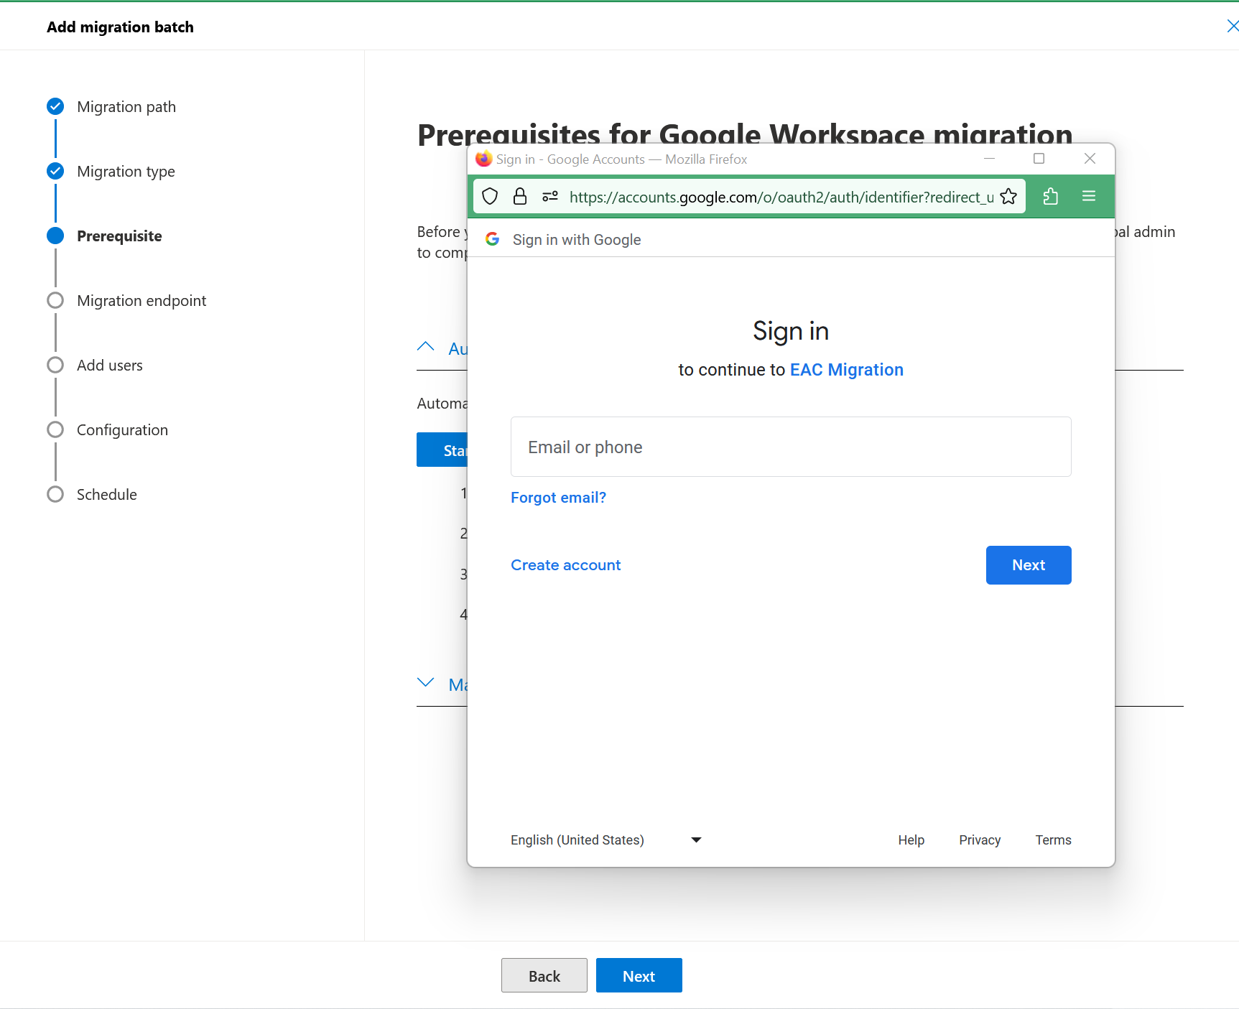
Place a check in See, edit, configure, and delete your Google Cloud data and see the email address for your Google Account. Click Continue.
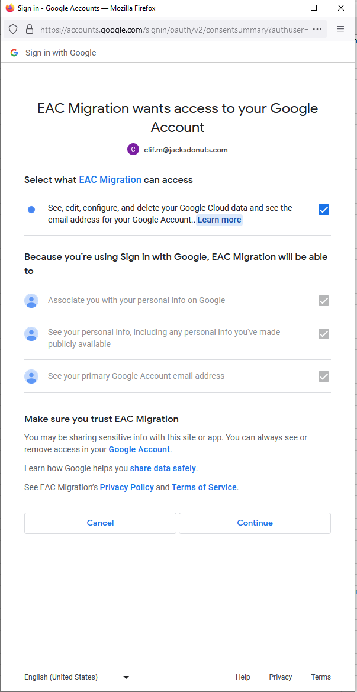
- You should receive a banner that APIs were successfully validated and see check marks for all tasks. You will now need to make sure you copy the ClientID and the Scope, as you will be using those in the next step. You will also notice a ‘json’ file downloads to your machine. We will grab this later. If the autoconfiguration fails, please follow this link to manually set up the connection Migrate mail from Google Workspace to Microsoft 365 (manual method) | Microsoft Learn
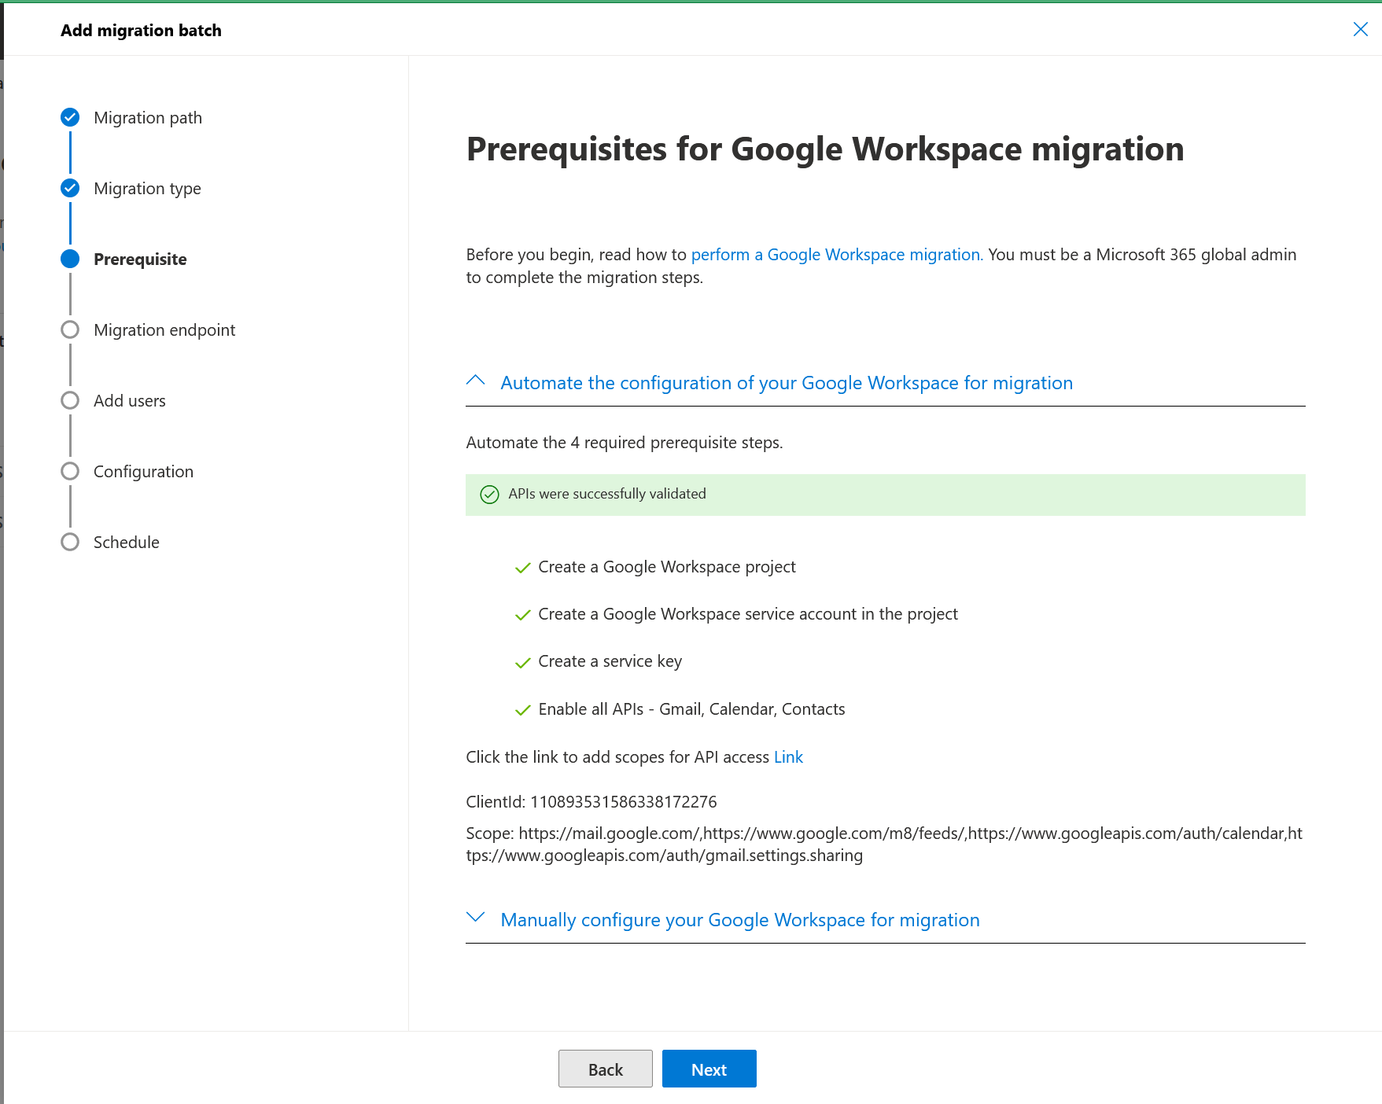

- Click the link “Click the link to add scopes for API access Link” and this will open Google Admin in another tab. This step displays a 403 error message if not a Super Admin in Google Workspace
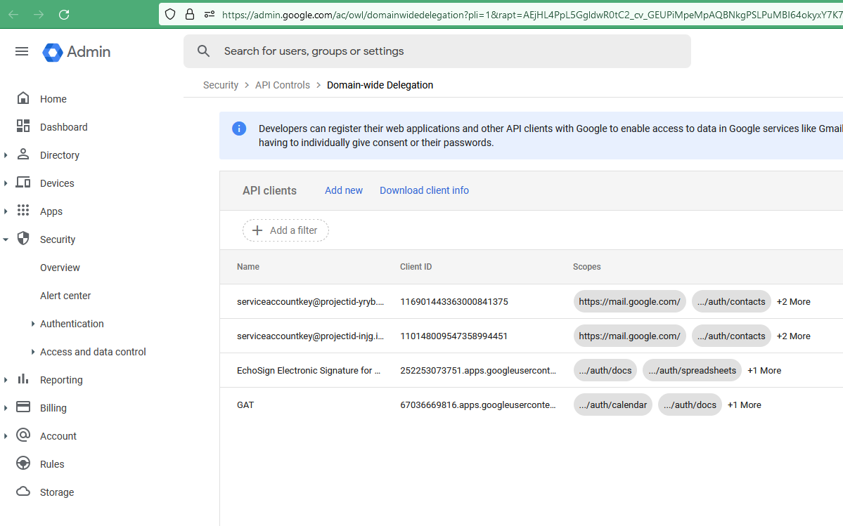
- Click on “Add new” and you will see the “Add a new client ID” window pop up. Input your client ID and your OAuth scopes by copying and pasting from the M365 window.
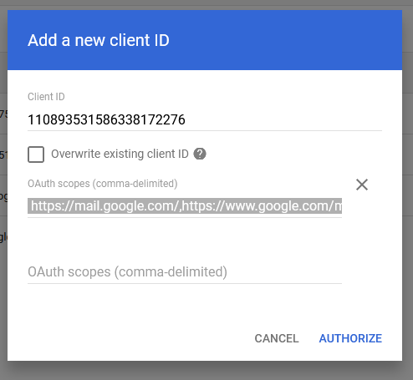
- Click “AUTHORIZE”
- Back in M365, click “Next”. If you get an error here, or anywhere going forward about Google calendar, or feeds, or API, don’t panic. It just means the workspace API in google was not accessed, and needs to be visited. Please see the Troubleshooting section at the end.
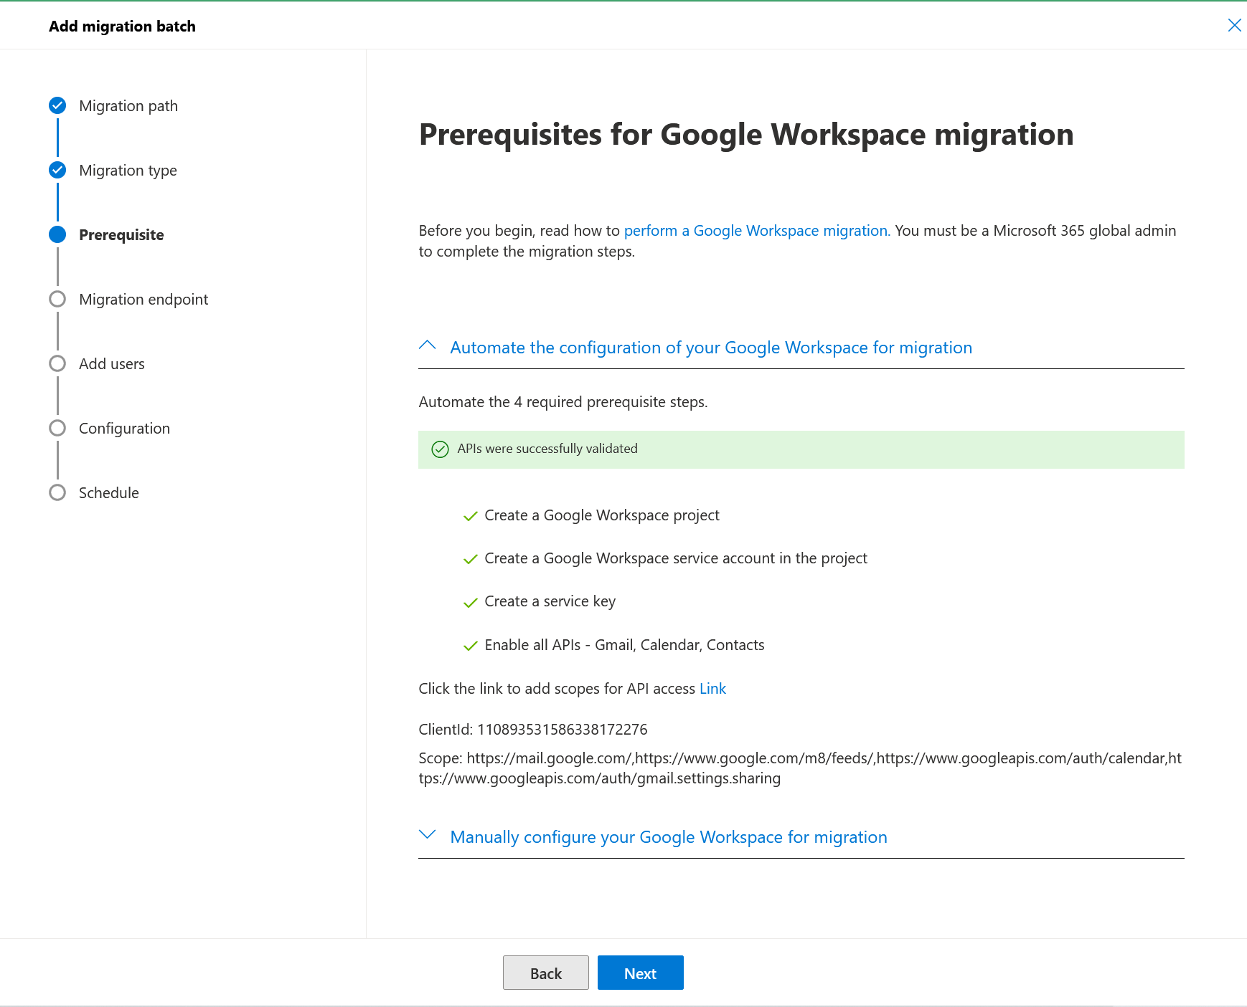

- Set a migration endpoint “Create a new migration endpoint”
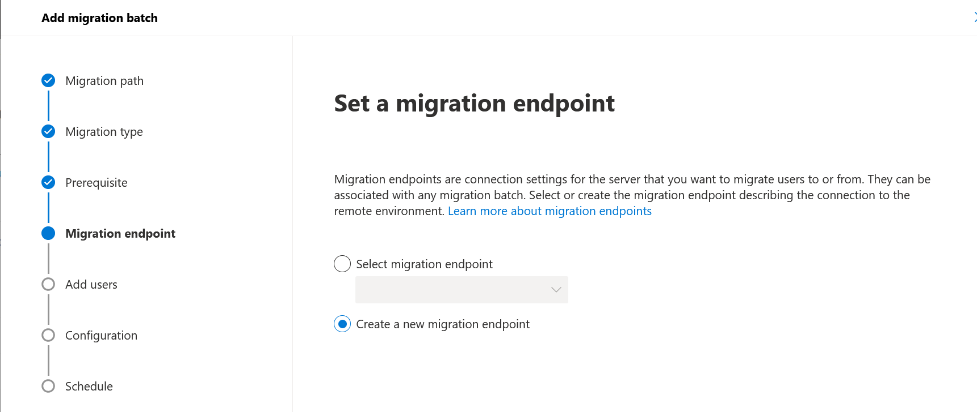
- Create a unique migration endpoint name. Leave the maximum values to default (20 and 10, respectively)
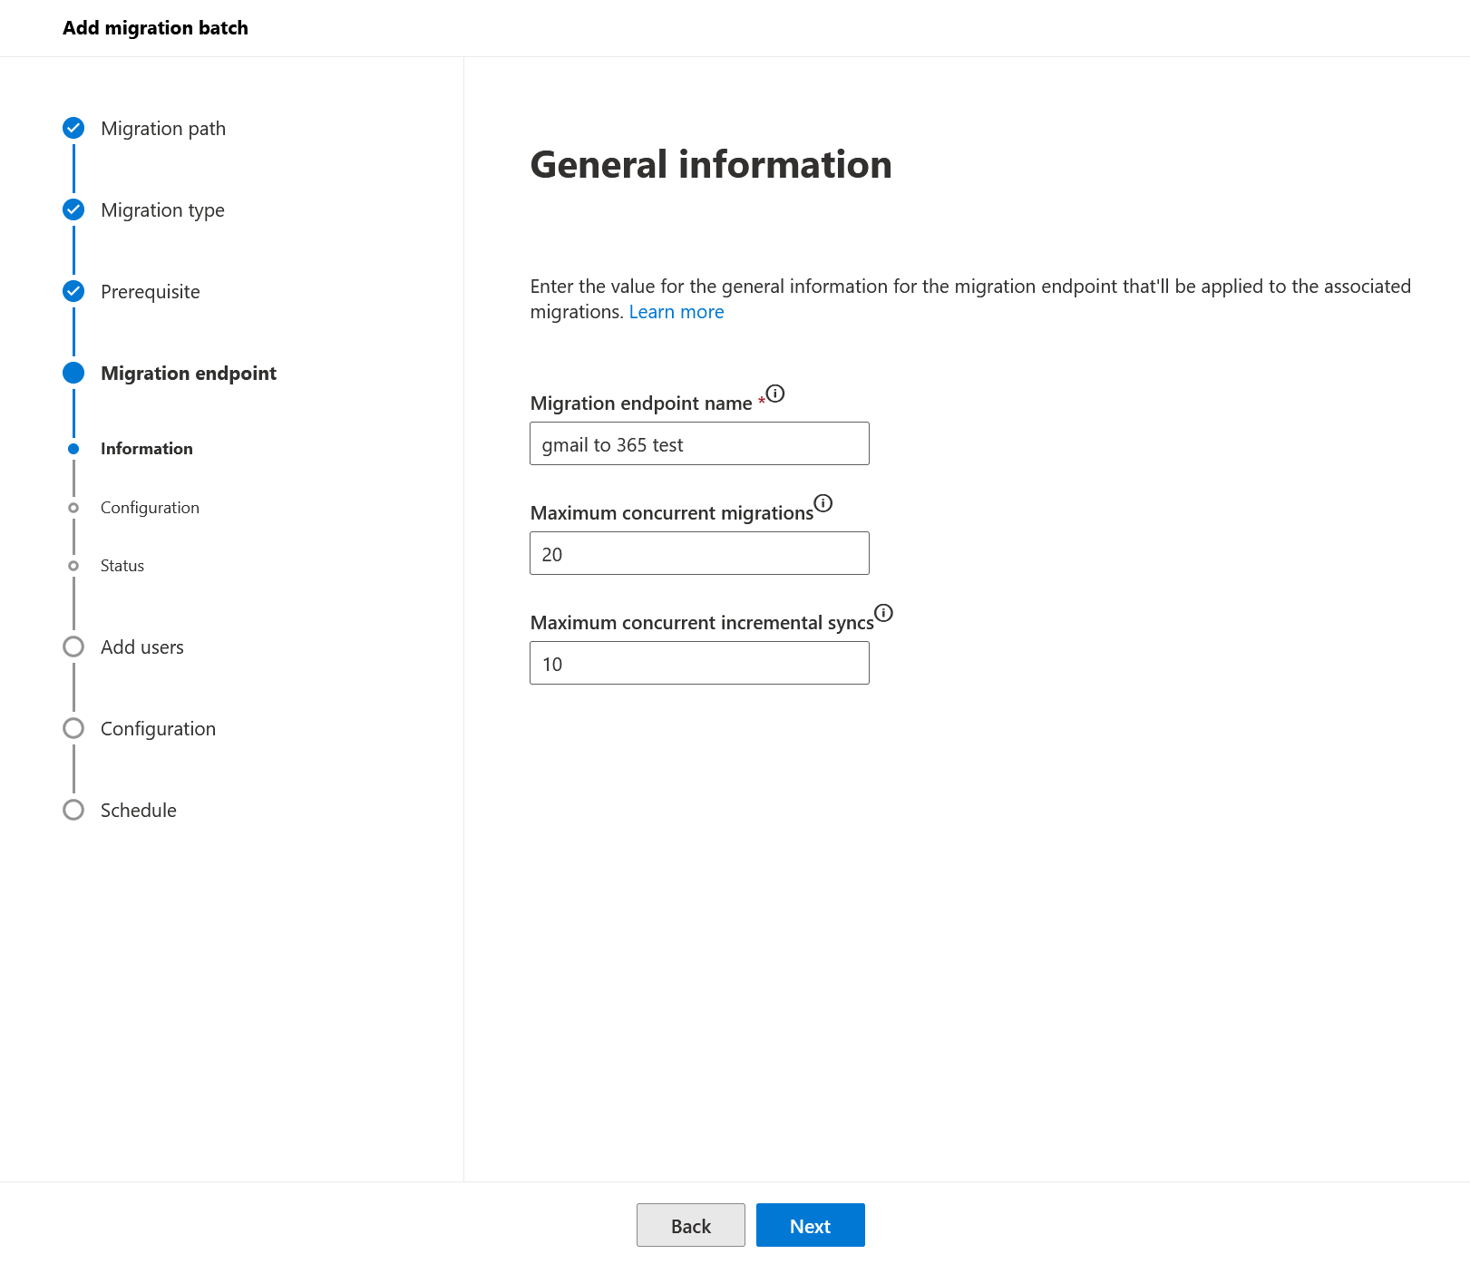
- Import your json file and input your Google admin email address, and click next:
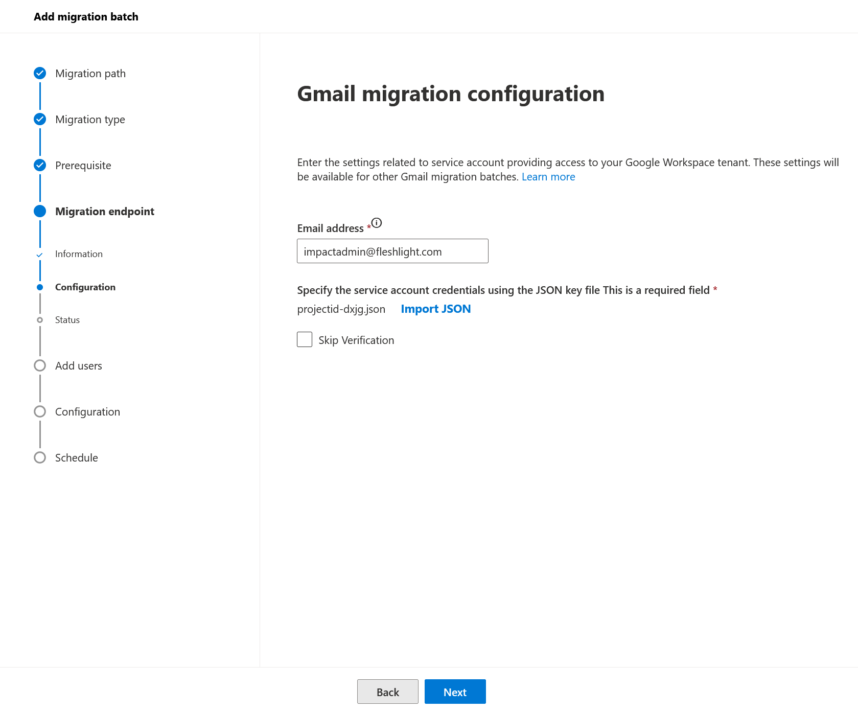
- Validate your endpoint is created and click next.
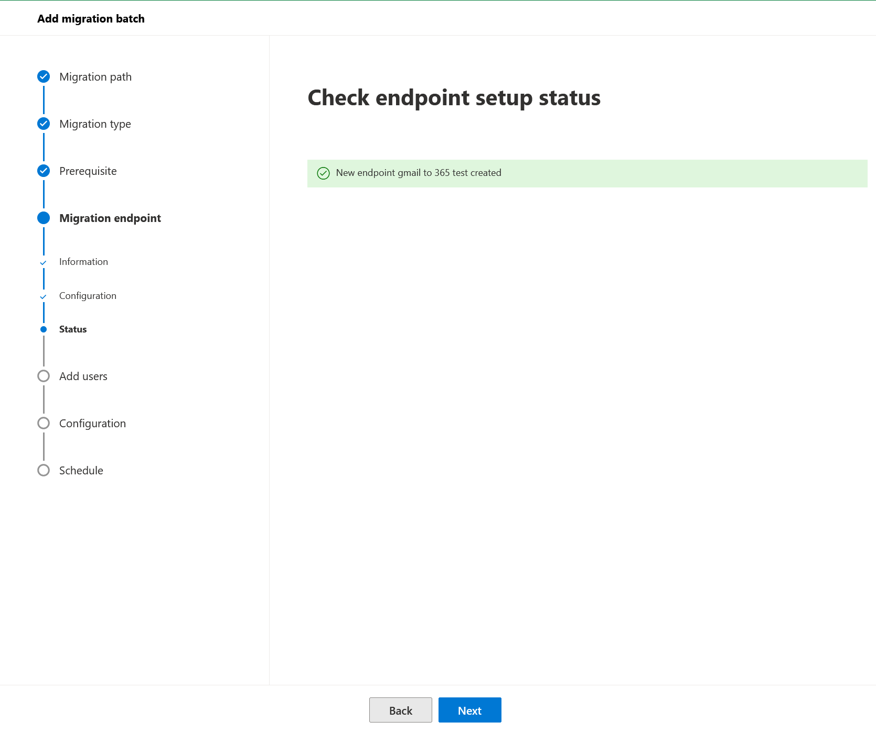
- Import your csv file for users. This is the manual csv file you had to create with the two columns “EmailAddress” and “UserName”. Click next.
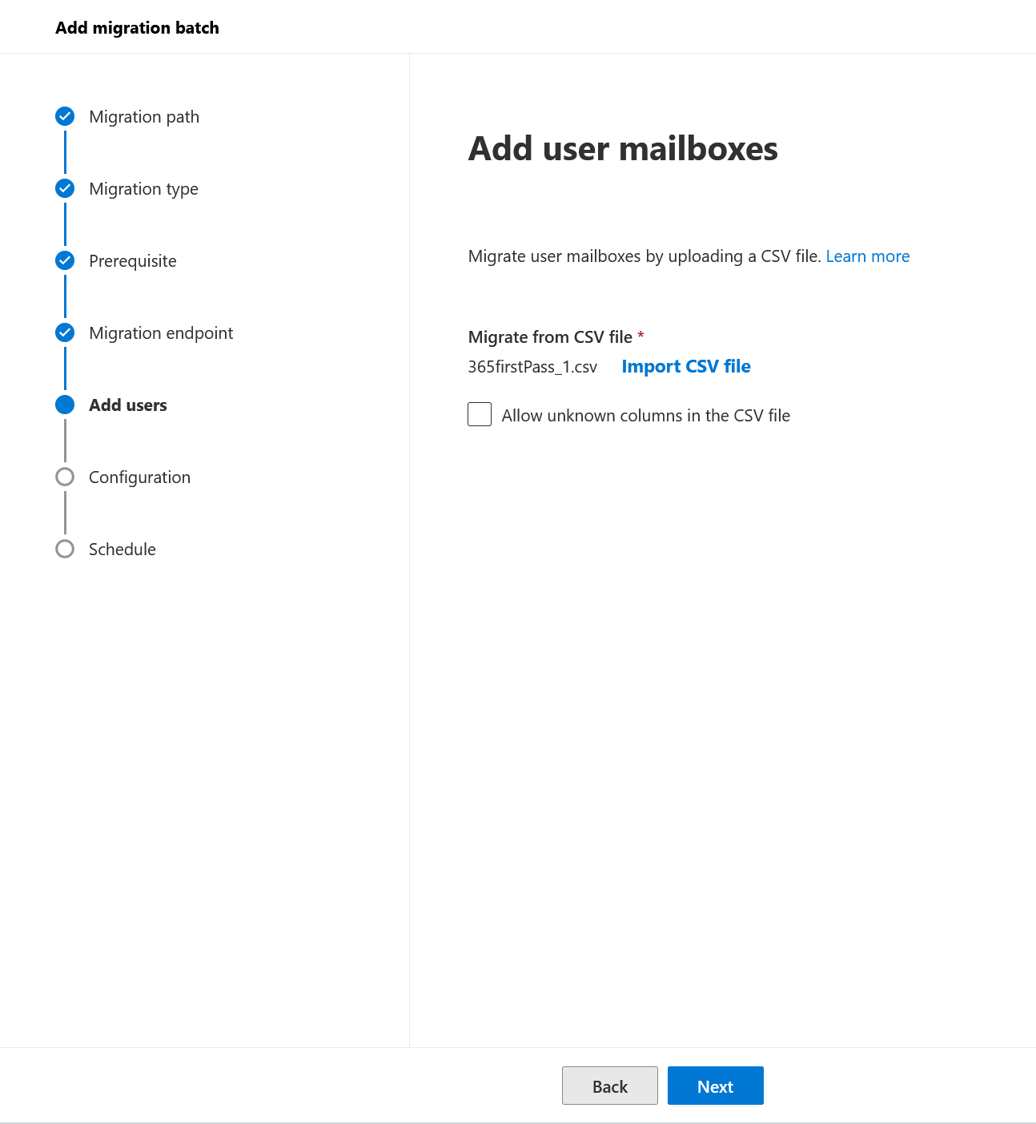

- Input your Target delivery domain into the box, unless it is already available via dropdown. This will be the 365 domain you are migrating to. Usually this will be something.onmicrosoft.com at this stage in the migration. In the example, it is not. If you would like to skip certain folders by name, or migrate by time range, you can select these options now. When you are ready, click “Next”
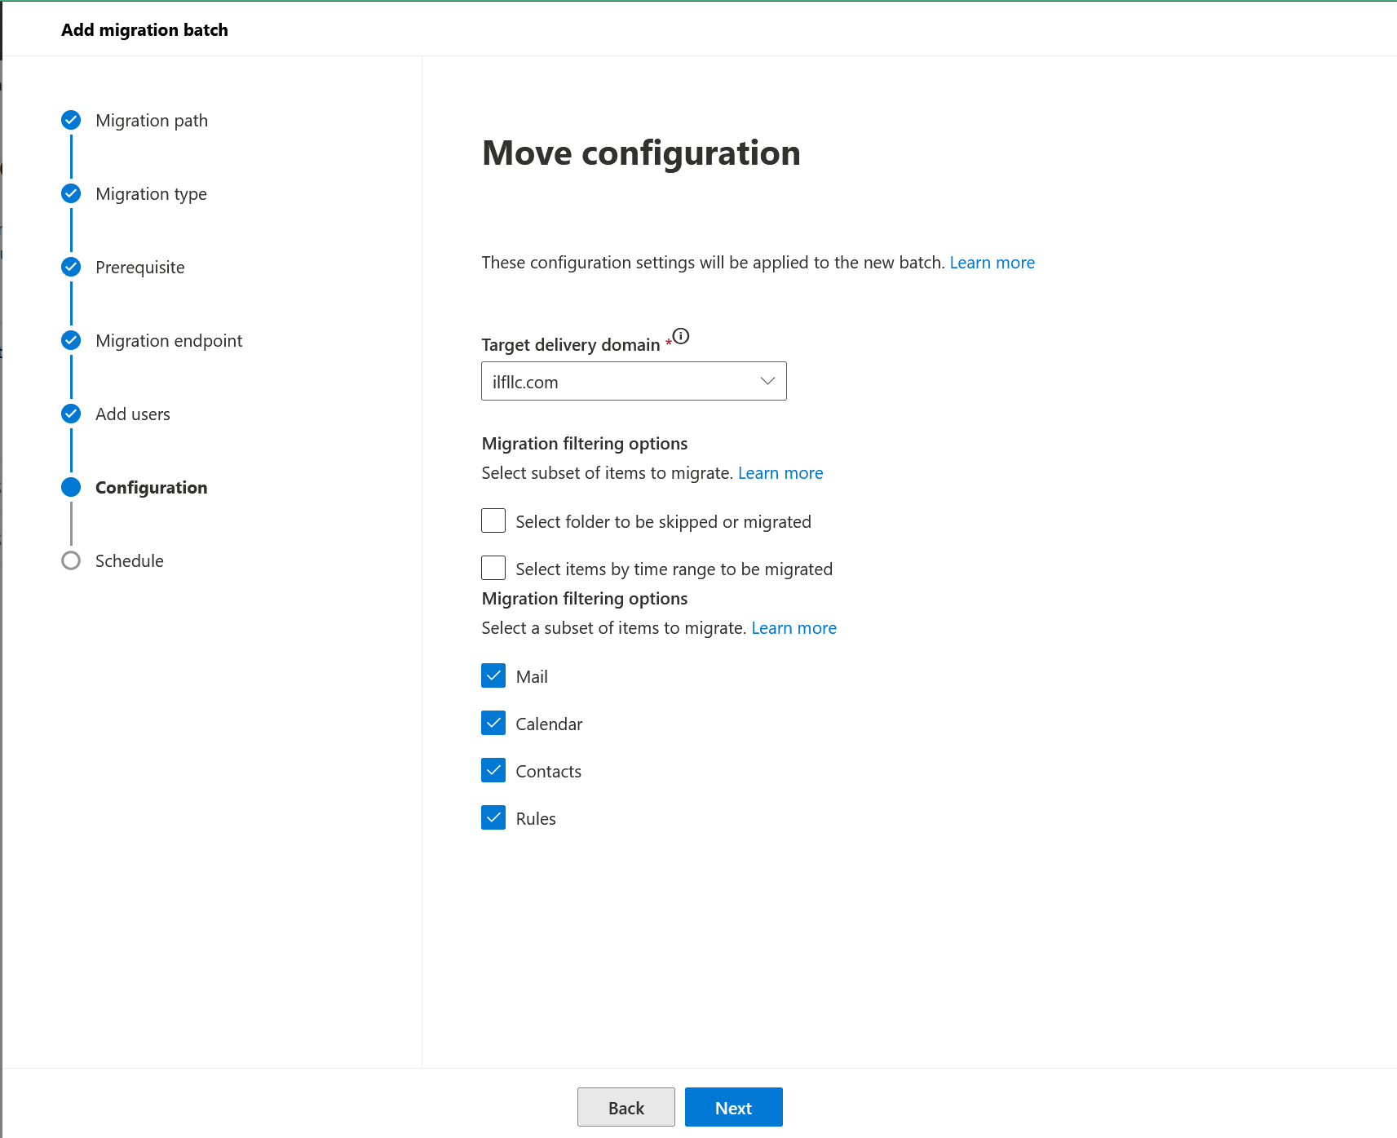

- You are now ready to schedule the migration, and setup your alert email address. Once you have input the parameters you would like, click “Save”.
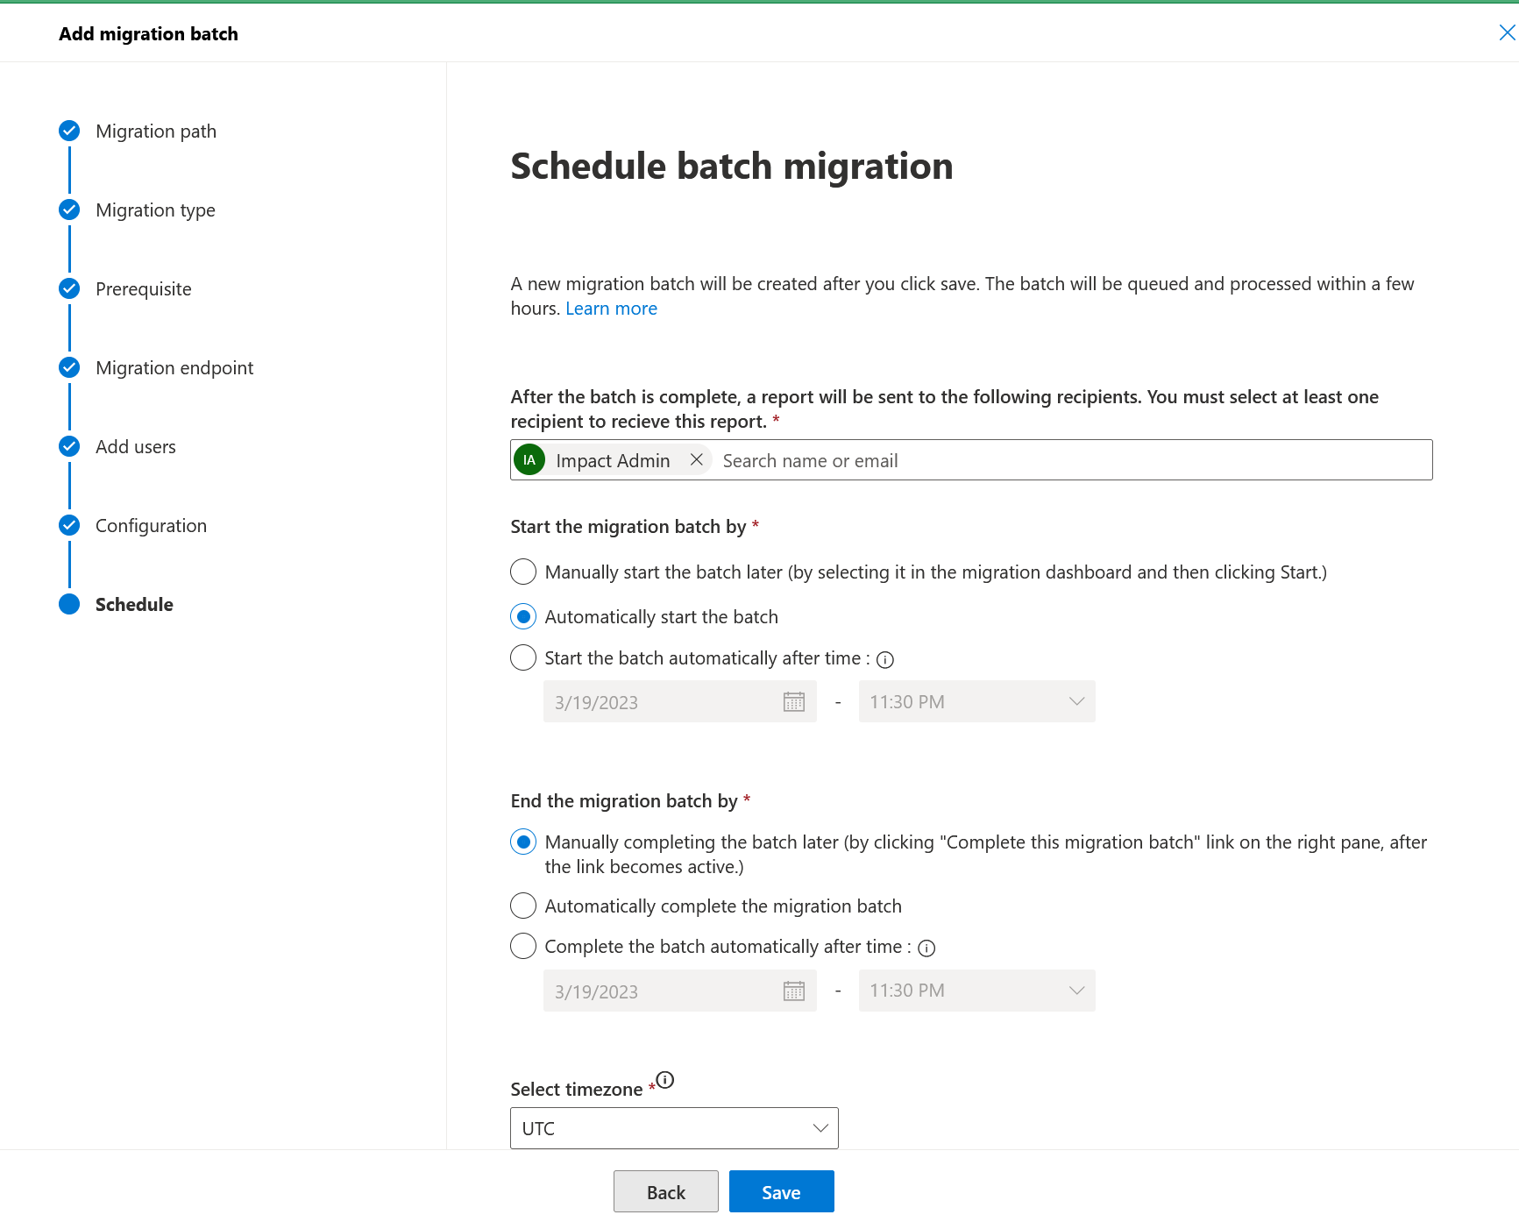
- You can now monitor your migration progress from “EAC -> Migration -> Migration batches
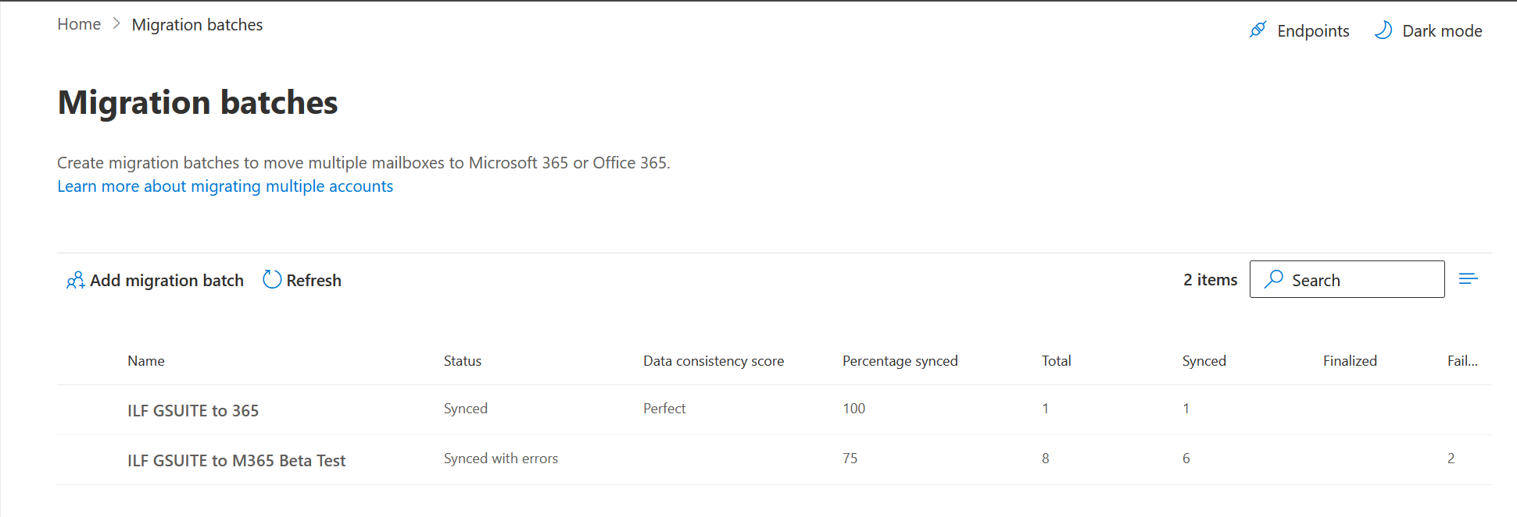

Troubleshooting
If you get the error about API permissions, or Calendar API, please visit the following URL and select your M365 Project. It just means the API project is not “activated” and the url needs to be visited. (https://console.cloud.google.com/apis/dashboard) and click on the Google Calendar API and People API at the bottom:
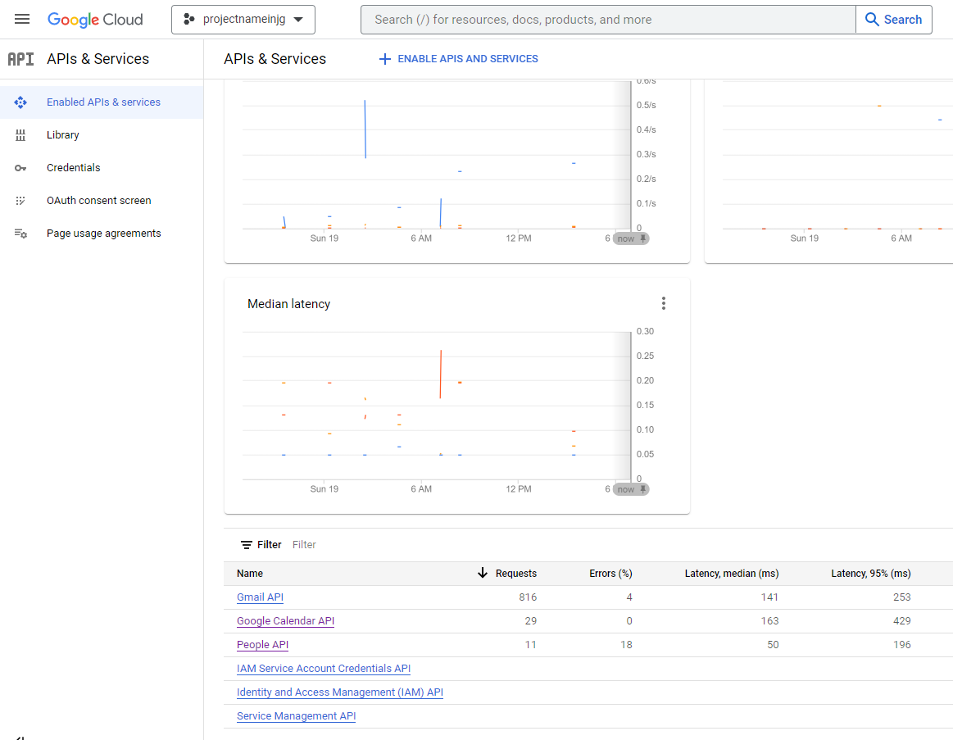

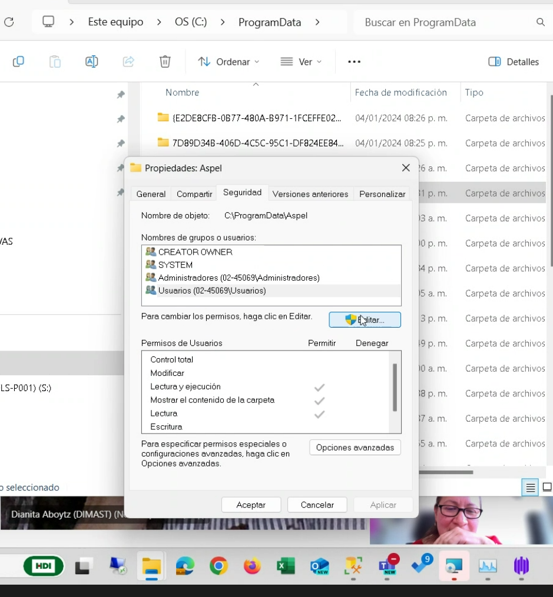

Group migrations
Groups do not get migrated by any of the normal means, either BitTitan or Microsoft tools. The posts that ay be in those groups need to be export using the Google Takeout and then imported. The process is not straight forward due to the different formats from each side
Steps:
- Add the impactadmin account to each group
- Make the impactadmin account an Owner of each group
- Login to https://takeaway.google.com with the impactadmin account
- Click Deselect All 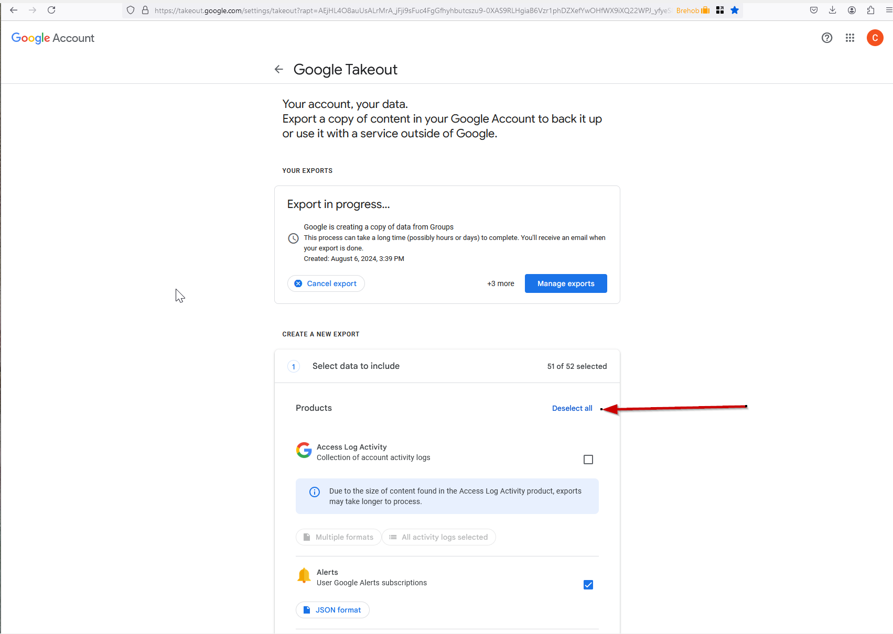
- Scroll down to groups and put a check in the box 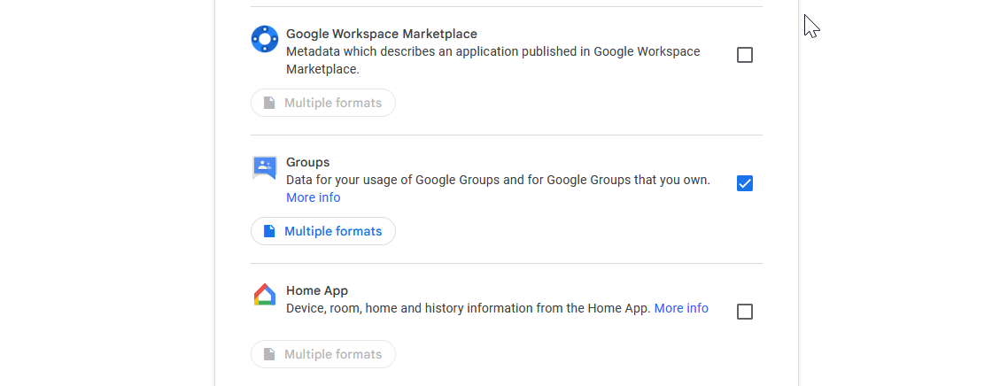
- Scroll down to the bottom of the page and choose Next Step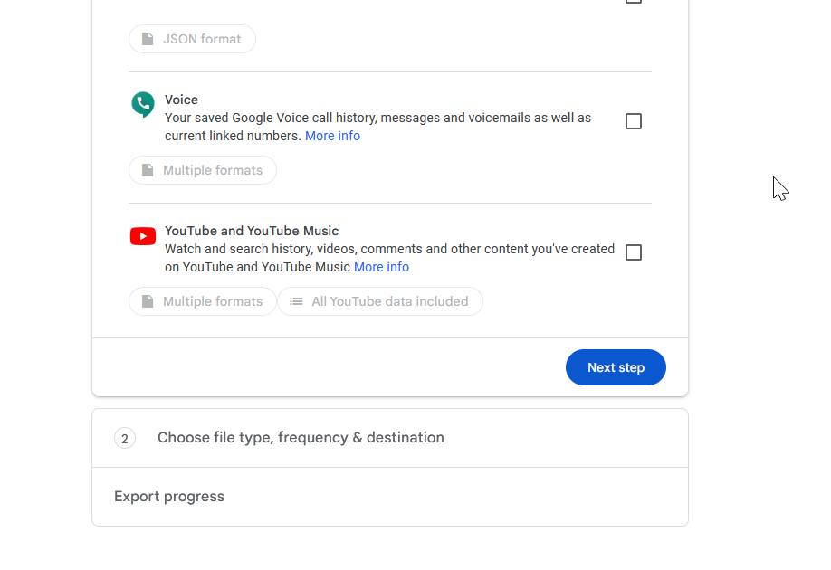
- Change the file size to 10 GB and press Create export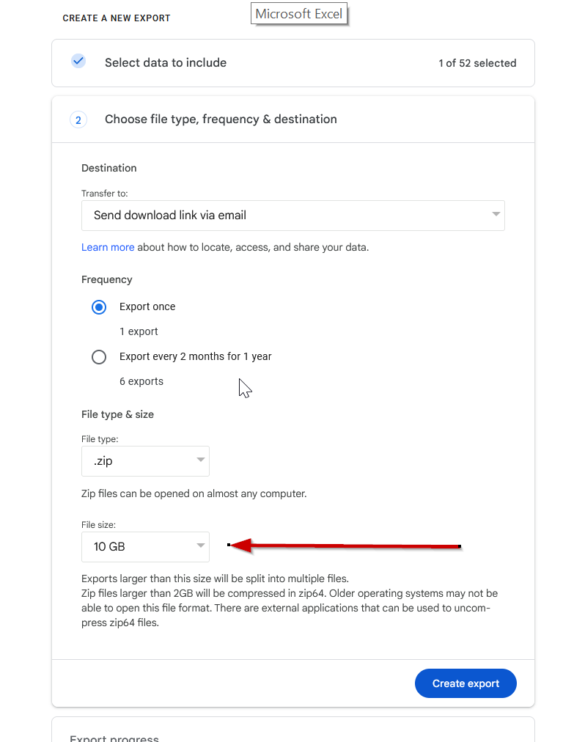
- Let the export finish and download it.
- Expand the zip file that is created
- Start Thunderbird. Login with the Impactadmin account to Gmail.
- Click on the Hamburger icon and choose Add Ons and Themes
- Search for ImportExportTools NG and click Add to Thunderbird
- Go back to the mail tab.
- Right Click on Local Folders and create a new folder. Call it the same as the group
- Right click on the folder and choose ImportExportTools NG -> Import MBOX file -> Individual mbox files
- Once imported there will be a folder named topics that will be created and all emails will be created there. Depending on the size it may take a minute, so be patient
- After all of the mail is imported we need to now export the mail. Right click on the topics folder and choose ImportExportTools NG -> Export All Messages in Folder -> EML Message Format -> Messages and HTML Index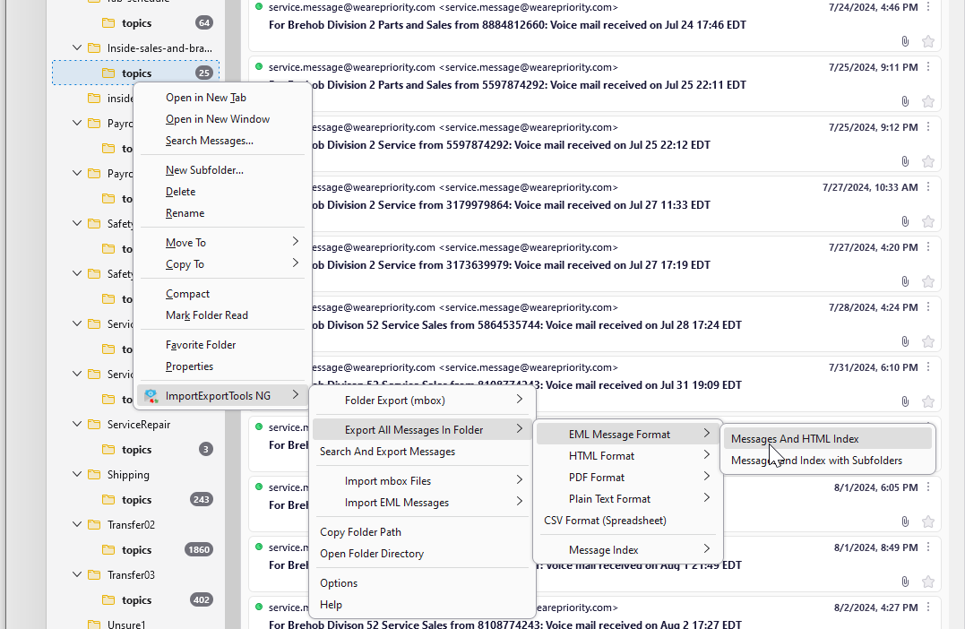
- Enter an easy place to find as the export and export the mail
- Download and install https://www.coolutils.com/TotalMailConverter/Email-to-PST Total Mail Converter. This will allow conversions for up to 30 days of EML to PST
- Browse to the folder that the EML files were exported to and click the Check All at the bottom of the page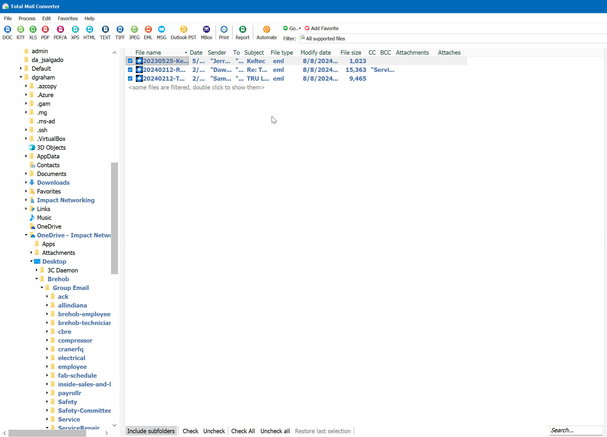
- Click the Outlook PST button at the top and then enter the name of the PST file. IF there are many EML files, on the filter tab you can filter by years or such to help with file size. Please note that every so-often a prompt will appear to inform you that the application has not been paid for. I found this to happen between every 100 to 200 mails (and maybe more frequently). Just keep hitting the blue button to accept until the conversion completes
- Log into Outlook with an account on the new O365 domain that has Full dlegate rights to the new location, assuming it is a Shared folder
- Open the PST that was just created
- Copy the email over from the mounter Outlook Folder to the correct Shared folder or what not.
- You are now done. Congratulate yourself for a job well done.

